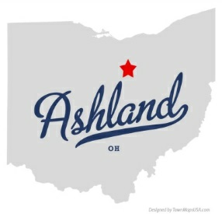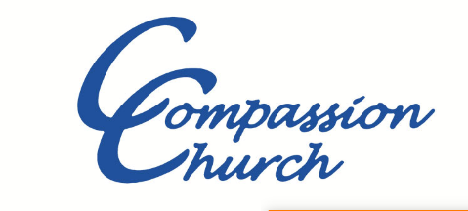

Comp s

**The McKenzie’s**

**July ~ 2022**

Hello everyone!

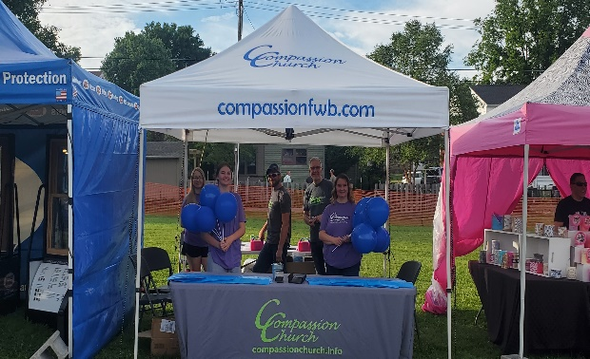Allow me to begin by saying, God is SO good! Our summer outreach events have been going very well! During the last weekend of June, we hosted a booth at the Ashland Balloon Festival. It was an honor to have Brad Ransom from North American Ministries join us for this outreach event. We were able to give away about 3,000 balloons with our logo and web address on them. We also gave away about 500 Compassion Church brochures, which all contain a presentation of the gospel! In addition to this, we were able to have many great conversations about the Lord with the hundreds of people who passed our booth. As a result, we had two families join us for service in the weeks to follow.

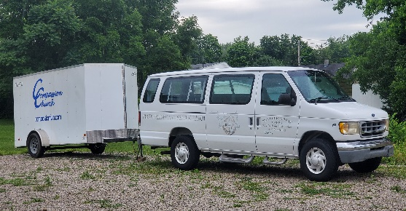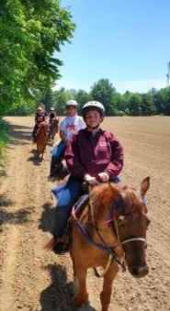I mentioned last month that our numbers were down. Well, during this time, we’ve been preparing for new families to join us in the future. One way that we’ve been doing this is to begin actively working with the young people who are already in the church. There are about 5 teenagers currently attending Compassion Church. We have a couple who has begun taking the teens on outings and having teen Bible studies. We’re just trying to reach them where they’re at in life! One thing that the church has needed to help foster this aspect of the ministry, and for our multiple outreach events throughout the year, is a van. Well, God blessed us to receive an amazing gift from the Clyde First Free Will Baptist congregation! They gave us a 15-passenger van! It is in excellent condition and has been taken care of very well! We are looking forward to using it as we ***“Reach others”*** for Christ in our community! As the summer rushes by, we are looking forward to several upcoming outreach events! In the first week of August, Compassion Church will be sponsoring a school supply give away and family carnival. We also will be participating in the Ashland County Cancer Association’s ***“No Child fights alone”*** family fun day the last weekend of August. There, we will set up all our carnival games for the children to come and enjoy the afternoon.

Then, in September Compassion church will have a booth at the Ashland County fair. During this time, we’ll also celebrate five years as a congregation! Again, God is So good! There is much to plan for, and much to do. We are always excited when we have an opportunity to show the community of Ashland the love of Jesus! After all, that’s why we’re here!

Thank you all so much for your faithful partnership with Compassion Church. Without you, we could not reach Ashland for Christ! Stay safe, stay healthy, God bless!

In Christ’s service,

Travis, Melissa & Rachel McKenzie

**Phone #** (419) 566-8487 ~ **Email:** [pastort@compassionfwb.com](mailto:tmckenzie126@gmail.com)

Published by North American Ministries - Compassion Church is a Free Will Baptist NAM/Ohio Home Missions Church